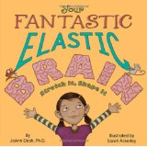
GATE Group Lesson: Sept. 25, 2015
Brain Basics Lesson
Learning Target: I can understand different parts of my brain and how they help me.
1. I began by handing each of your children a rubber band, and asking, "What should a rubber band make you think about?
2. After some discussion, I read the first pages of our theme book: "Your Fantastic Elastic Brain" by JoAnn Deak, PhD.
3. Your children learned about the parts of the brain, and then labeled them on a "brain map"--This brain map and other activities we will work on, will be stored in a "Brain Journal".( I will keep them at school so we can add to the journal with each GATE group session.)
a. Cerebrum-largest part and helps us think and speak
b. Cerebellum-small part at the back of the brain that helps your muscles to coordinate your movement and balance, so that you can walk, ride a bike, or play tag.
c. Prefrontal Cortex-the part of your brain behind your forehead that lets you make plans and decisions
d. Hippocampus- is at the center of your brain and works like a file cabinet to help you store and find memories.
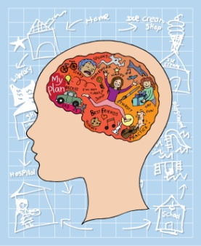
e. Amygdala- is a tightly-packed group of cells deep within the center of the brain that controls your emotions.

4. After the labeling of our brain maps, I asked some review questions:
a. What is a brain?
b. How big is your brain?
c. What does your brain look like?
d. Why do we have a brain?
e. What does your brain do?
f. Do all living creatures have a brain? (all vertebrates have brains, and most invertebrates. Only a few invertebrates such as sponges, jellyfish, adult sea squirts and starfish do not have brains. They have localized nerve nets instead.)

5. The final question above lead me to the last part of our session, and that was sharing a real calf brain with your children!!!!! Each student was given the opportunity to hold the calf brain if they wished! NOT to worry, they had gloves on!!! (I took photos and will share them with you as well!!
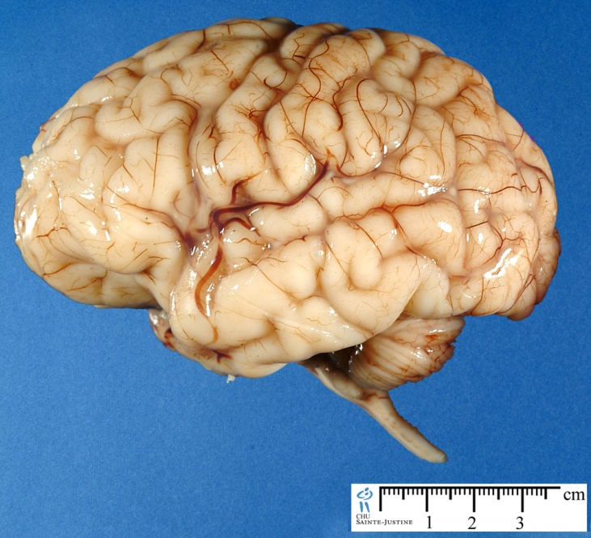
I do think this was the highlight of the lesson today! A big thanks goes out to Kari Kurowski, one of our high school science teachers, as she shared the calf brain as well as the plastic human brain model with us!!

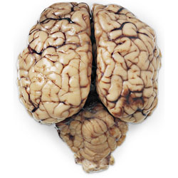
Human brain Calf Brain

